Carbon Monoxide Transmitter

Model : CO-T1
PRODUCT DESCRIPTION  Most building codes require a very high ventilation rate in enclosed parking or areas involving vehicle repairs and operation. This must be provided during all hours of use. Most codes allow fans to be operated intermittently as long as carbon monoxide (CO) level does not exceed 25 or 50ppm (check local code). A CO sensor can reduce fan energy costs by switching off or reducing ventilation when CO level is low.  The CO-T1 is a CO sensor/transmitter designed specifically for these applications. It delivers all the advantages of electrochemical sensing in a durable, long life (5-year) package and at attractive low price. The loop powered sensor delivers a linear 4~20mA output that is easily integrated into any building control, ventilation or alarm system. | 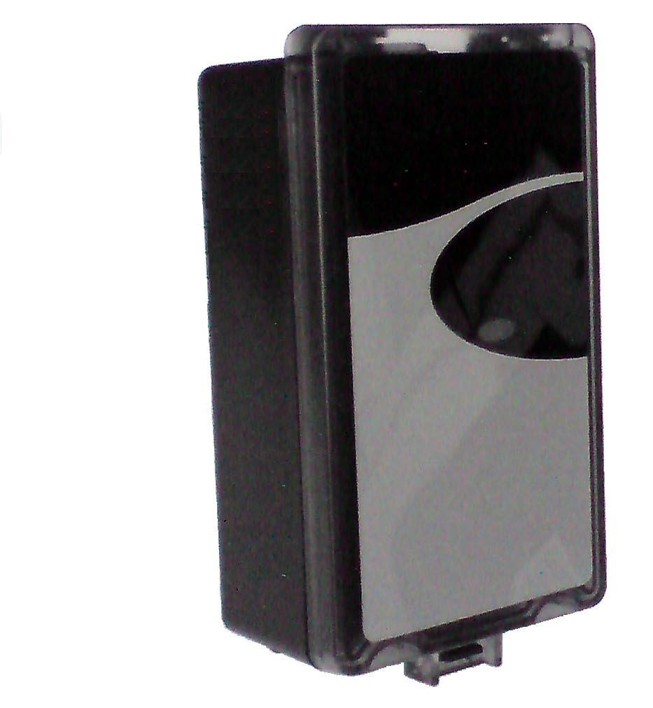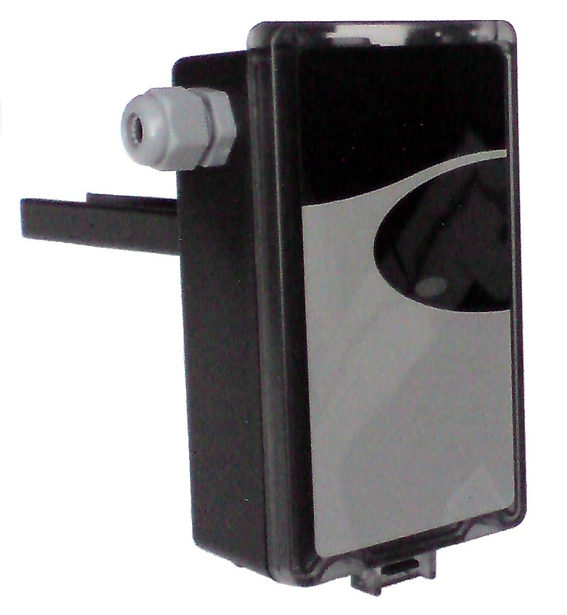  CO-T1 CO-T1KS  Wall mount model duct mount model  (white housing) (black housing)
FEATURES  - Using carbon monoxide electrochemical cell, the CO-T1 offers fast and reliable measurements over a long period of time;  - Measurement range: 0 - 100 ppm CO  - Two-wire 4-20mA linear output signal corresponding to the measurement range  - Long sensor life, up to 5 years  - non-frill design; cost-optimized and loop powered for direct connection to DDCs  - Easy sensor head replacement minimizes long term operating costs  - Optional measurement range (0 ~ 200ppm or 0 ~ 400ppm)  - Optional terminals for temperature sensing elements such as PT100, PT1000 or NTC 10K.  - Optional duct mount (-IP65) housing | SPECIFICATIONS  General Sensing Method: Electrochemical Sensor Rated Life: 5 years Temp Operating Conditions: 0 to 50 ºC Humidity Operating Conditions: 0 to 90 %RH Storage Conditions: -40 to 70 ºC  Performance CO Measurement Range: 0 to 100ppm Repeatability: +/-5% of measured value Linearity: +/-5% of measured value Recommended Calibration: 12 months Response Time: T90 =< 60 seconds Warm Up time: less than 2 minutes  Power Input: 18 ~ 30 VDC Power consumption: 20mA  Outputs Adjustment: Span Output signal: 4 ~ 20mA Terminal Wire Size: 16 ~ 22 AWG

CO-T1 WIRING
Controller with Voltage Input Controller with 4 ~ 20mA Input
24VDC +
Power supply -

24VDC +
Power supply -

Telasia Symtonic Pte Ltd
• 47, Jalan Pemimpin, #02-07, Sin Cheong Building • Singapore 577200 •
Homepage: www.telasia.net
Phone no.: +65 6547 1155 • Fax no.: +65 6547 1151 • E-mail: telasia@pacific.net.sg
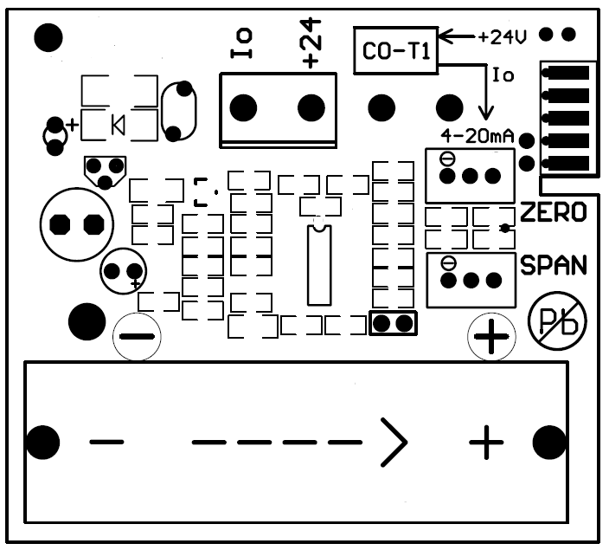
Analog input +
(2 ~ 10V input)

Controller
-

Analog input +

Controller with
4~20mA input
-

External 500 ohm
Load Resistor

